NIKKI’S HOME STAY

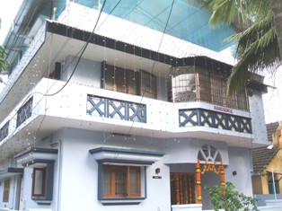

Location - Gujarathi Road, Mattacncherry is just 20 minutes from Ernakulam South Railway Station and one hour from Cochin International Airport.

This Home Stay is very near to all the sight seeing locations like Dutch Palace, Jewish Synagogue, Bolgatty Island, Chinese Fishing Nets, Kalady, Munnar, Periyar ( Thekkady), Guruvayoor, Chottanikkara, Village Backwater Cruiser in Country Boat, Athirapally and Vazhachal Waterfalls, Trivandrum, Kanyakumari, Kovalam Beach, Spice Market, Asia’s biggest saree centre etc.. You will really have a homely feeling and will enjoy the god gifted scenic beauty of Kerala. Take back the beautiful unforgettable memories of Cochin by staying at Nikki's Home Stay at the rates and facilities given below :

 | Non A.C. Double Occupancy - per day | Rs. 500/-
 | Extra person – per person | Rs. 100/-
 | A.C. Double Occupancy - per day | Rs. 1,200/-
 | Extra person – per person | Rs. 100/-
 | Group- Maximum 10 persons- per day | Rs. 2,500/-

- 3 Non A.C.Rooms self contend with 24 Hrs.hot water.
- 1 A.C.Room self contend with 24 Hrs.hot water.
- 2 Common halls with T.V.,DVD player.
- Zero ‘B’ Filtered drinking water.
- Drying facility on terrace.
- Special Masala Tea in morning – Complementary.
- Home made Lunch or Dinner on request in advance – Charges applicable
- Airport/Railway Station Pick-up & Dropp service, sight seeing or any other travelling, transport facility available on request – Charges applicable.

Last but not the least, treat Nikki's Home Stay as your own home. You can get up, go and come, rest as you wish. So what are you waiting for. Book your stay before it is already full by calling at the following numbers.

Neha Kelkar – 91-9869176599
Madhu Paranjape – 91-9969105383
kelkar.neha@yahoo.com or nehankelkar@gmail.com
nanduk_ind@yahoo.com

